Tutorial 6.1: FHRP
c) With reference to Figure 2-3a and Figure 2-3b, HSRP have not been fully configured on R2. Write a configuration on R2 to enable VLAN10 as backup and VLAN20 as primary with priority 105. Remove unnecessary configurations.
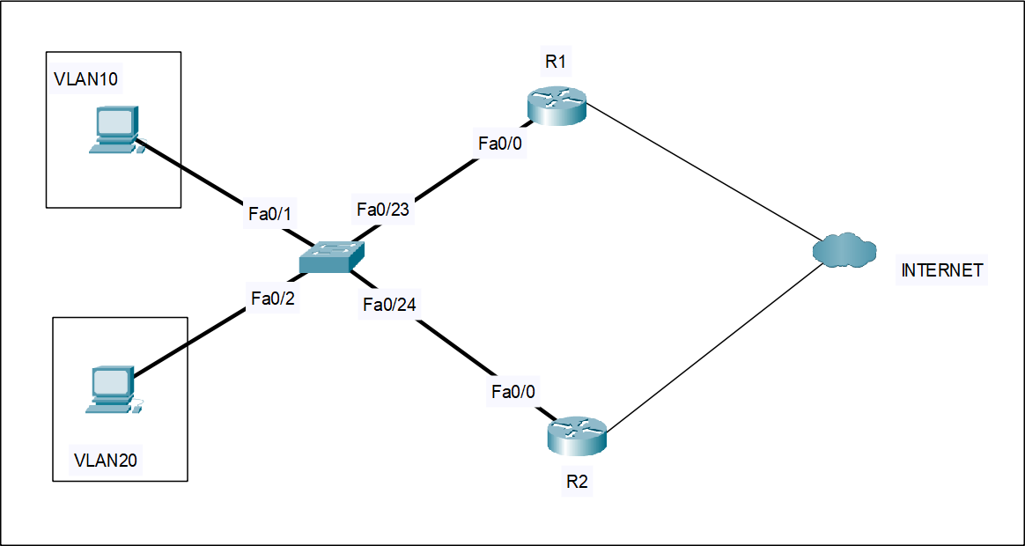
Figure 2-3a: A HSRP Networ

R1#show running-configuration  Building configuration…  …  interface FastEthernet0/0 no ip address  !  interface FastEthernet0/0.10 encapsulation dot1Q 10  ip address 192.168.10.1 255.255.255.0  standby 1 ip 192.168.10.3  standby 1 priority 105  standby 1 preempt  !  interface FastEthernet0/0.20 encapsulation dot1Q 20  ip address 192.168.20.2 255.255.255.0  standby 2 ip 192.168.20.4 | R2#show running-configuration  Building configuration…  …  interface FastEthernet0/0 no ip address  !  interface FastEthernet0/0.10 encapsulation dot1Q 10  ip address 192.168.10.2 255.255.255.0  standby 3 preempt  !  interface FastEthernet0/0.20 encapsulation dot1Q 20  ip address 192.168.20.3 255.255.255.0  standby 4 preempt
Figure 2-3b: Partial HSRP configurations for R1 and R2

(4 marks)

int FastEthernet0/0.10
no standby 3 preempt
standby 1 ip 192.168.10.3

int FastEthernet0/0.20
no standby 4 preempt
standby 2 ip 192.168.20.4
standby 2 priority 105
standby 2 preempt

